Lab 05

Configuring Static Routing on Networks In Cisco Packet Tracer

Lab Objectives:

- Design and implement a network topology consisting of multiple LANs connected through a router
- Configure basic IP addressing and subnet configurations on all network devices
- Configure static routing on the router
- Verify network connectivity among the LANs using appropriate testing commands
- Learn how to create some basic networks in Cisco packet tracer by creating various LANS and then connecting them through routers for the routing.

Background/ Scenario:
In this activity you will build a simple network in Packet Tracer from scratch and then save the network as the packet tracer activity file. We will configure static routing on the routers

STATIC ROUTING
Static routing is a form of routing that occurs when a router uses a manually-configured routing entry, rather than information from dynamic routing traffic. In many cases, static routes are manually configured by a network administrator by adding in entries into a routing table, though this may not always be the case. Unlike dynamic routing, static routes are fixed and do not change if the network is changed or reconfigured. Static routing and dynamic routing are not mutually exclusive. Both dynamic routing and static routing are usually used on a router to maximise routing efficiency and to provide backups in case dynamic routing information fails to be exchanged.

Procedure:
Build a Network in the Logical Topology Workspace
Launch Packet Tracer
Double click on the Packet Tracer icon on your desktop or navigate to the directory that contains the Packet Tracer executable file and launch Packet Tracer. Packet Tracer should open with a blank default Logical topology workspace as shown in the figure.
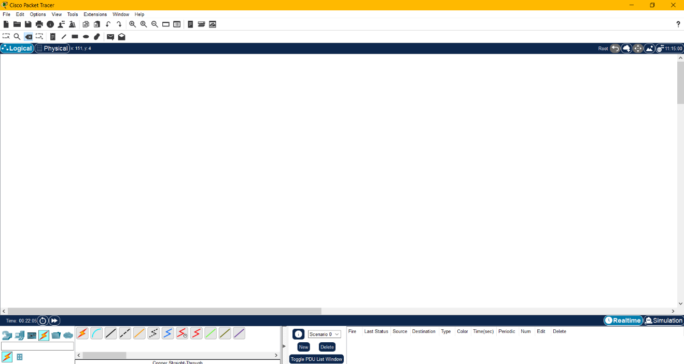

Build the topology
Add network devices to the workspace.

Using the device selection box, add the network devices to the workspace as shown in the topology diagram.

To place a device onto the workspace, first choose a device type from the Device-Type Selection box. Then, click on the desired device model from the Device-Specific Selection box. Finally, click on a location in the workspace to put your device in that location. If you want to cancel your selection, click the
Cancel icon for that device. Alternatively, you can click and drag a device from the Device-Specific Selection box onto the workspace.

Draw the below topology in Cisco Packet Tracer by assigning IP’s to all the devices and do any other settings required. For configuring the Static routing on routers follow the steps given below.
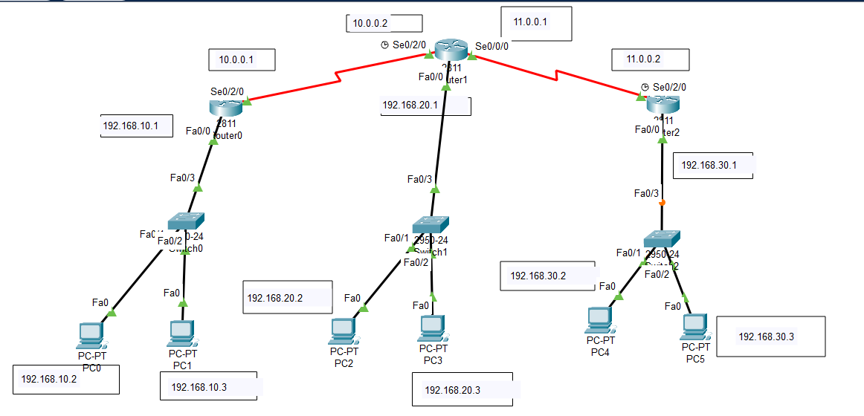

For static routing do the following settings on each router separately
For router 0
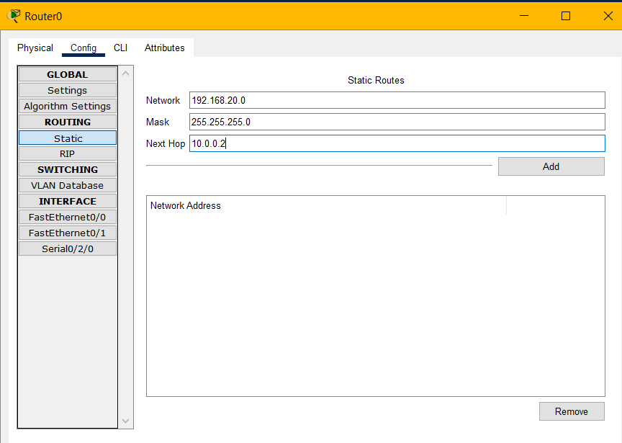
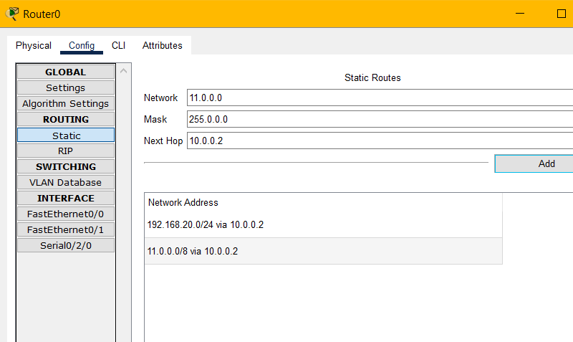

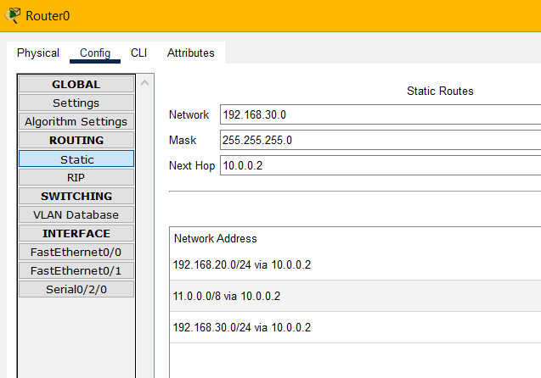

For router 01
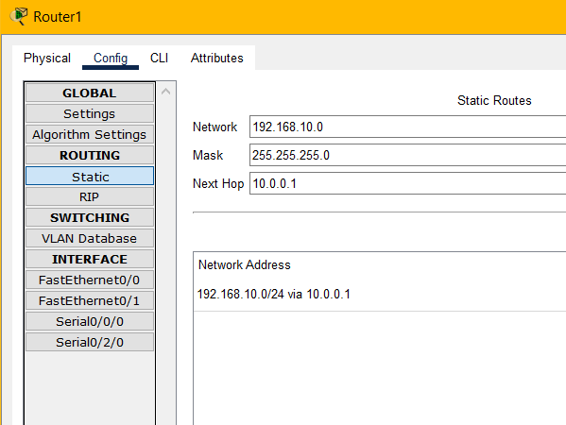

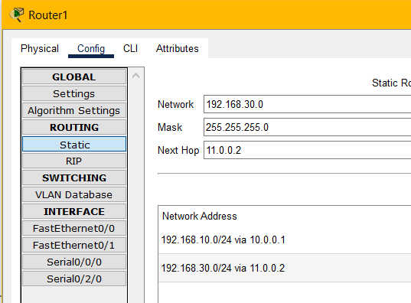

For router 2
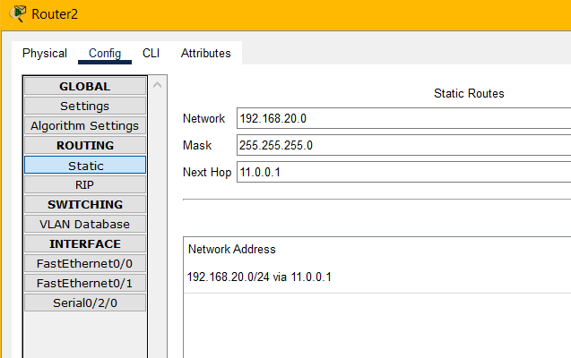

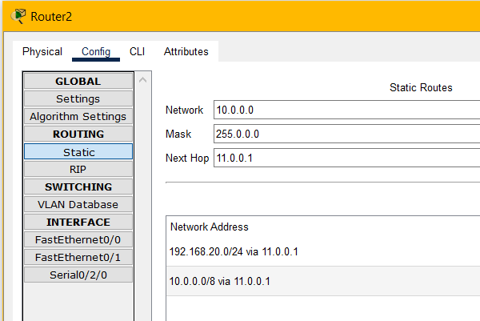
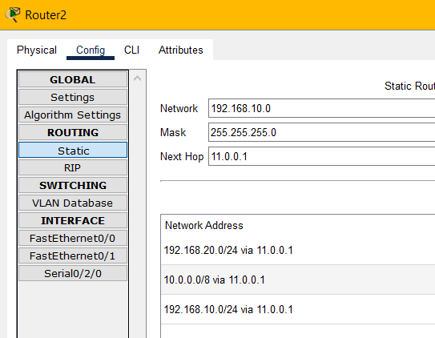

TASKS:
- Design the topology given in Figure 01 in Cisco Packet tracer and configure static routing on the routers. Then verify the connectivity of all the devices. [5 marks]
Figure 01

- Draw and configure the topology given in Figure 02 in Cisco Packet tracer by using any IP configurations. Configure static routing on all the routers. Then Verify the connectivity of all the devices. (5)

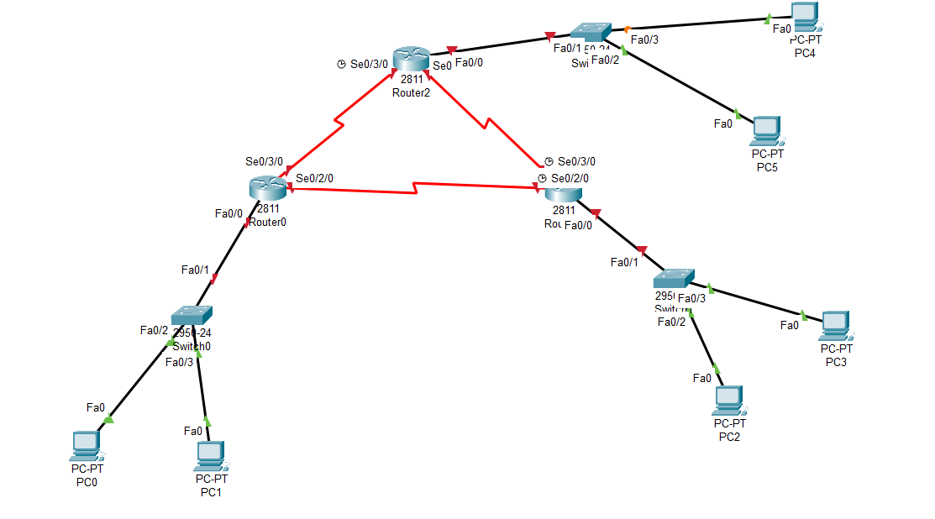
Figure 02

